Appositive Series

🔹 What is Appositive Series?
# Source: AI Source: Provided by: [Data Path: Persons Table -> ID Column: 1, Name_En Column: Motasem Essam] -> From: [Chatgpt (GPT‑5 Mini)] on [8/7/2025]
An appositive series is a group of two or more nouns or noun phrases placed next to another noun to rename or further explain it. These items form a series (or list) within the appositive structure.

🔸 Key Features:
# Source: AI Source: Provided by: [Data Path: Persons Table -> ID Column: 1, Name_En Column: Motasem Essam] -> From: [Chatgpt (GPT‑5 Mini)] on [8/7/2025]
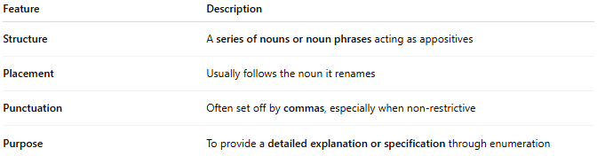
Feature | Description
Structure | A series of nouns or noun phrases acting as appositives
Placement | Usually follows the noun it renames
Punctuation | Often set off by commas, especially when non-restrictive
Purpose | To provide a detailed explanation or specification through enumeration

🔸 Examples:
# Source: AI Source: Provided by: [Data Path: Persons Table -> ID Column: 1, Name_En Column: Motasem Essam] -> From: [Chatgpt (GPT‑5 Mini)] on [8/7/2025]
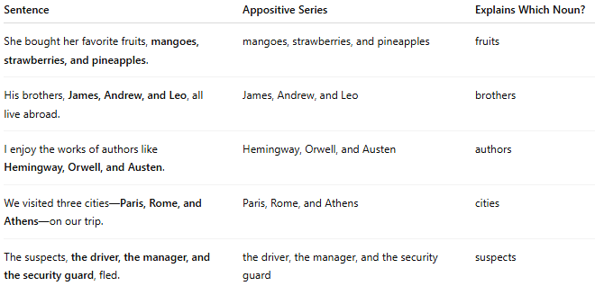
Sentence | Appositive Series | Explains Which Noun?
She bought her favorite fruits, mangoes, strawberries, and pineapples. | mangoes, strawberries, and pineapples | fruits
His brothers, James, Andrew, and Leo, all live abroad. | James, Andrew, and Leo | brothers
I enjoy the works of authors like Hemingway, Orwell, and Austen. | Hemingway, Orwell, and Austen | authors
We visited three cities—Paris, Rome, and Athens—on our trip. | Paris, Rome, and Athens | cities
The suspects, the driver, the manager, and the security guard, fled. | the driver, the manager, and the security guard | suspects

